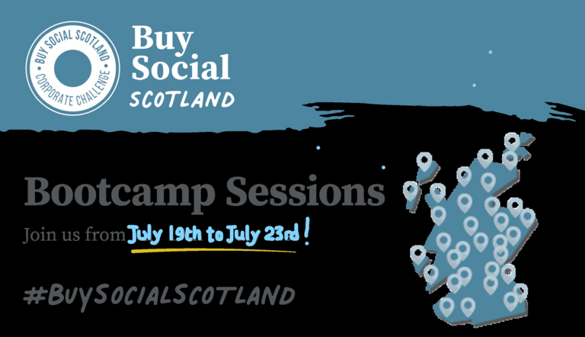
Book your place at these FREE support sessions
These sessions are designed for all social enterprises interested in supply chain and procurement.
Monday 19th July – Opportunities for Social Enterprise
- Naomi Johnson will take us through recent data collected through our survey and highlight the upcoming sessions in this boot camp series.
- Alistair Kerr will guide us through what it means to be a 'supported business' and the opportunities this can bring.
- Jamie Lawson, Haven PTS will also join us offering his practitioner experience.
Tuesday 20th July – Pitching and proposals
- Gillian Cameron, Supplier Development Programme will highlight the support on offer to social enterprise organisations.
- Following on, we will hear from Colin Downie. Wildhearts. While Wildhearts are now part of the supply chain for a number of large companies this has not always been the case. As with all businesses Wildhearts have had to learn how to pitch, who their potential customers are and remain competitive to win business
Wednesday 21st July – Policy perspectives
- Barry Phillips - Scotland Excel. Barry speaks passionately about supported business and social enterprise and we're delighted he's able to join us for this session as we hear about the legislation driving social impact through procurement.
- Yvonne McBride - P4P. Yvonne leads P4P, a dedicated programme for social enterprise organisations who want to develop procurement partnerships and collaboration opportunities.
Thursday 22nd July – Private sector engagement
- Jim Johnstone, Morrison Construction - Morrison Construction have taken an innovative approach to working with social enterprise/third sector organisations. They are signed up on the SES Corporate Challenge programme and have worked with the team at P4P as they look to engage social enterprise organisations as part of their supply chain.
- Graham McWilliam, CEO at Glencraft – Based in Aberdeen this social enterprise has its products in top hotels. overnight trains and has a Royal Warrant and international sales.
Friday 23rd July – Procurement Action Planning – interactive workshop
- Delivered by Angela Porte of Mora Consulting this online workshop will get you working in teams as you look at Impact Assessment.
- As a Sustainable Development Goals Action Manager, you will consider the options and impacts as you look at socially led procurement and the steps you may or may not take moving forwards.
THIS IS A LIVE SESSION ONLY – NO RECORDING WILL BE AVAILABLE

