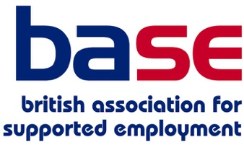
Raising Aspirations Poster Set

Order Form

Please send me a set of Raising Aspirations posters at £24 per set (incl. vat) plus postage.

Your name:

Email:

Phone number:

Number of poster sets required:

Please indicate your preferred postage option:

24 hour tracked delivery (£7.65 each)
First class post (£6 each)
Second class post (£5.30 each)

Invoicing details
Please invoice as follows:

Name of organisation:

Invoicing address:

Purchase order number *

* A purchase order number is required for all public sector organisations

Delivery address
Please state the delivery address (if different to invoicing address):

For attention of:

Please email this order form to admin@base-uk.org

