National Supported Internship Day (27th March 2023)
Media Pack

Welcome to the first communications pack for the inaugural National Supported Internship Day led by DFN Project SEARCH.
This pack contains information about the day, how you can get involved with various activities, as well as key messages and suggested social media posts to help you support this crucial awareness day, taking place on the 27th March 2023.
We will continue sharing more information as the day draws closer.
Primary Contacts
For any media, communications, or social media enquiries, please contact:
- Anne Perham: anne@integra-group.co.uk
- Roberta Kirosingh: Roberta.Kirosingh@dfnprojectsearch.org

Website: https://www.dfnprojectsearch.org/national-supported-internship-day/

Social Media
We would love you to help spread the word about the National Day of Supported Internships to as many people as possible. This document offers several example social media posts, which can be tailored to suit your needs.
The primary DFN Project SEARCH channels are:
- Twitter: @DFNSearch
- LinkedIn: DFN Project Search
- Facebook: DFN Project SEARCH
Recommend hashtags include: #NationalSupportedInternshipDay and #NSID2023.

Key messages - The Story of National Supported Internship Day

The solution to many problems faced by young people with a learning disability, autism spectrum condition, or both is straightforward: competitive employment.

Yet only 4.8% of people in England (and 4.1% of people in Scotland) with a learning disability and/or autism who are known to local authorities go on to secure paid employment, compared to 80% of their peers.

We need to work together to change that.

DFN Project SEARCH is launching the first-ever National Supported Internship Day to raise awareness of the huge impact that a supported internship can have, not only on the life outcomes of the interns who take part, but on the host organisation and wider society too.

In 2022 we were awarded a government contract from the Department for Education, as part of a consortium working in partnership with the National Development Team for Inclusion (NDTi) and British Association of Supported Employment (BASE) to double the number of supported internships to 4,500 per year in England by March 2025.

That’s why we are calling on everyone – whether you are linked to the business, education or health sectors, local authorities, national government, the public, private and third sectors – to come together and challenge the everyday misconceptions and pre-set work cultures that all-too-often unfairly shape the lives of young adults with a learning disability and/or autism across the UK.

How To Get involved in the National Supported Internship Day

- Talk about it! Use our suggested social media posts to raise awareness of supported internships and show your support in the run up to, and during, 27th March 2023.

- Get in touch with your regional lead at NTDi and BASE to find out more about Internships Work.
  - This project is funded by the Department for Education and will double the current supported internship provision in England.
  - You can visit the Internships Work website via this link: https://www.ndti.org.uk/change-and-development/internships-work

- Become a Supported Internship Employer Champion.
  - Sign up to an Eventbrite session to learn more via this link: https://www.eventbrite.co.uk/e/employer-champions-for-supported-internships-tickets-518745209887?aff=ebdsoporgprofile

- If you or your organisation are already involved in a Supported Internship, take part in our social media competition by hosting an event or posting online about it.

Some ideas include: Running a coffee morning - Get a photo with a senior leader/CEO - Hold an online event to raise awareness of your programme - Invite local SEN students to visit - Invite employers to visit - Invite the LA to visit - Invite your local MP to visit - Get your local MP to tweet their support for your programme - Contact your local newspaper and post an article!

  - You can submit your entries by posting your content online with the #NationalSupportedInternshipDay or #NSID2023.
  - If the submission is a press release or in an alternative format, you can email it to Bethany.madigan@dfnprojectsearch.org
  - Winners will be announced on 31st March and they will receive a special prize from the CEO of DFN Project SEARCH.

- Write to your local MP and ask them to sign the National Supported Internship Day Early Day Motion (EDM) recognising the 27th March as an official awareness day.
  - See which MP has signed the EDM here: https://edm.parliament.uk/early-day-motion/60518

Suggested Social Media Posts

Tweet 1:

Today is the launch of National Supported Internship Day! Supported Internships are a work-based study programme for 16 to 24 years old with SEND.

We are celebrating the impact supported internships have for young adults and wider society and call on you to join us! #NSID203

Tweet 2:

Today is the launch of National Supported Internship Day!

Only 4.8% of people in England with a learning disability or autism are in full-time employment.

We need to work together to change that and call on you to join us! #NSID203

Tweet 3:

Today is National Supported Internships Day!

We provide @dfnsearch supported internships which shape the futures of our interns.

We are calling on you to support young disabled people into employment by becoming a supported internship provider #NSID2023

Facebook Post:

Today is National Supported Internship Day!

Did you know only 4.8% of people with a learning disability and/or autism who are known to local authorities go on to secure paid employment, compared to 80% of their peers.

Supported Internships are a work-based study programme for 16 to 24 years old with SEND and can help kickstart a young person’s career or put them on the path to employment. That’s why DFN Project SEARCH have launched National Supported Internship Day (NSID) to raise awareness of the impact of supported internships can have on the lives of young people. DFN Project SEARCH’s supported internships have seen up to 70% of their graduates gain paid employment, and it’s not just the interns who benefit but wider society benefits from a diverse talent pool.

That’s why we are calling on you to support young disabled people into employment.

Find out how to get involved here: www.dfnprojectsearch.org/national-supported-internship-day/

LinkedIn:

Today is #NationalSupportedInternshipDay!

Did you know only 4.8% of people in England with a learning disability and/or autism go on to secure paid employment.

We need to change this and that’s why we’re calling on YOU to support young disabled people into employment by becoming a supported internship provider.

Supported Internships are a work-based study programme for 16 to 24 years old with SEND and can help kickstart a young person’s career and put them on the path to employment.

That’s why @DFNProjectSEARCH have launched National Supported Internship Day (NSID) to raise awareness of the impact of supported internships can have on the lives of young people. DFN Project SEARCH’s supported internships have seen up to 70% of their graduates gain paid employment, and it’s not just the interns who benefit but wider society benefits from a diverse talent pool.

Find out how to get involved here: www.dfnprojectsearch.org/national-supported-internship-day/

#NSID #NationalSupportedInternshiDay #Autism #SEND

Social Media
How to create your own post using our template.
Step 1) Click on the link below and log-in with a method of your choosing.
- Click this link: https://www.canva.com/design/DAFai-IeErg/gRkc7f8PWUs3c7QY_nbkcA/view?utm_content=DAFai-IeErg&utm_campaign=designshare&utm_medium=link&utm_source=sharebutton&mode=preview
Step 2) Upload a photo of your choice and drag it onto the template in your desired position.
Step 3) Click the ‘Position’ button and press ‘Backward’.
Step 4) Save your design and post it!

We have also created a range of pre-made social media graphics that can be used when promoting National Supported Internship Day.
These include:
- 2 x Banner Graphics
- 3 x NSID Logos
- 2 x NSID Photos for Social Posts

See below for a preview, or click here to download: https://we.tl/t-LMTz5ToH3I

Banner Graphic 1
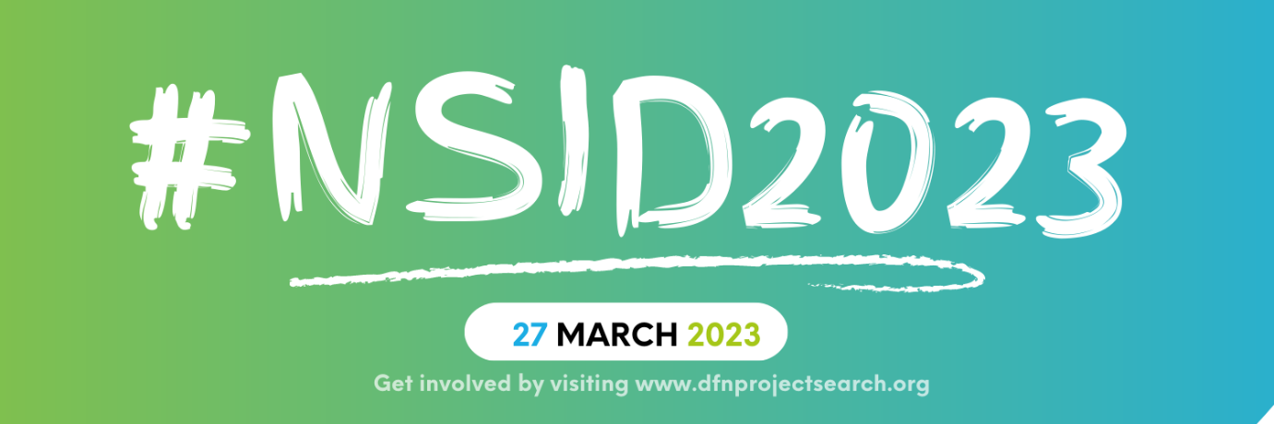

Banner Grahic 2

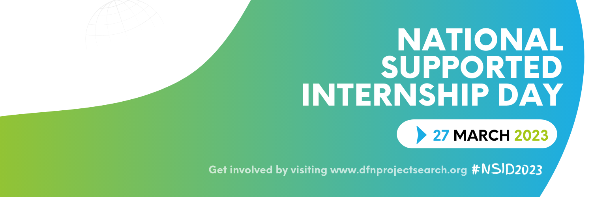

Logo 1

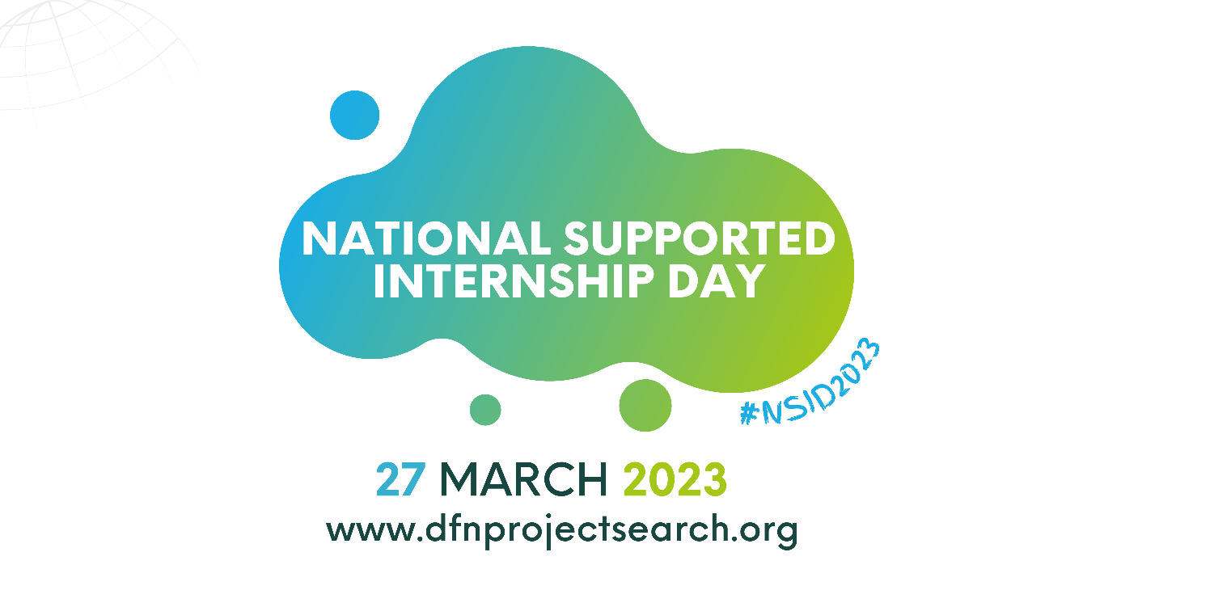

Logo 2

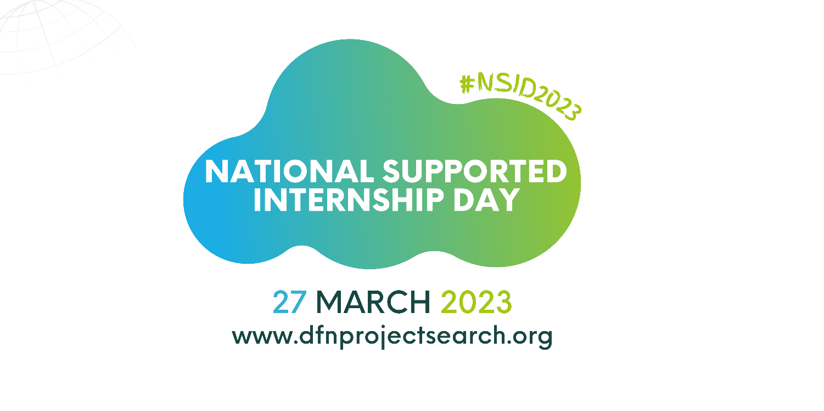

Logo 3
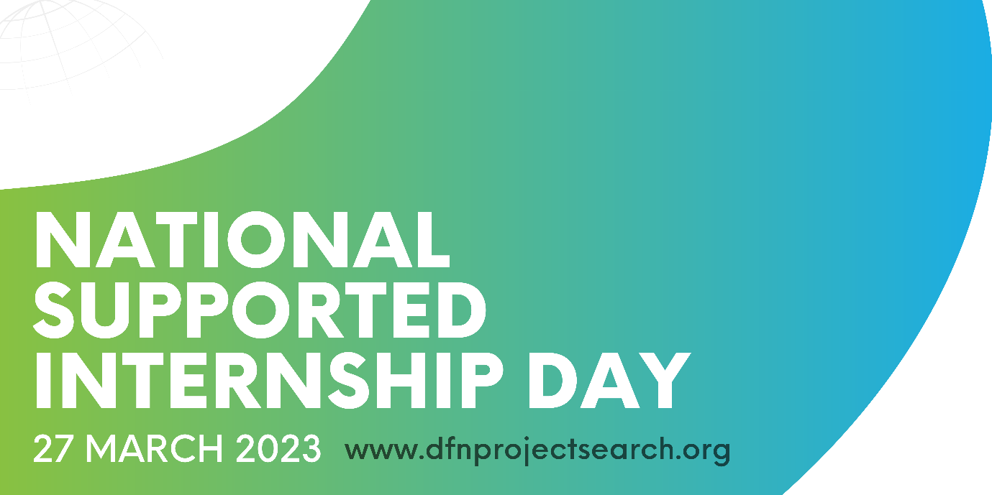

NSID Photo 1
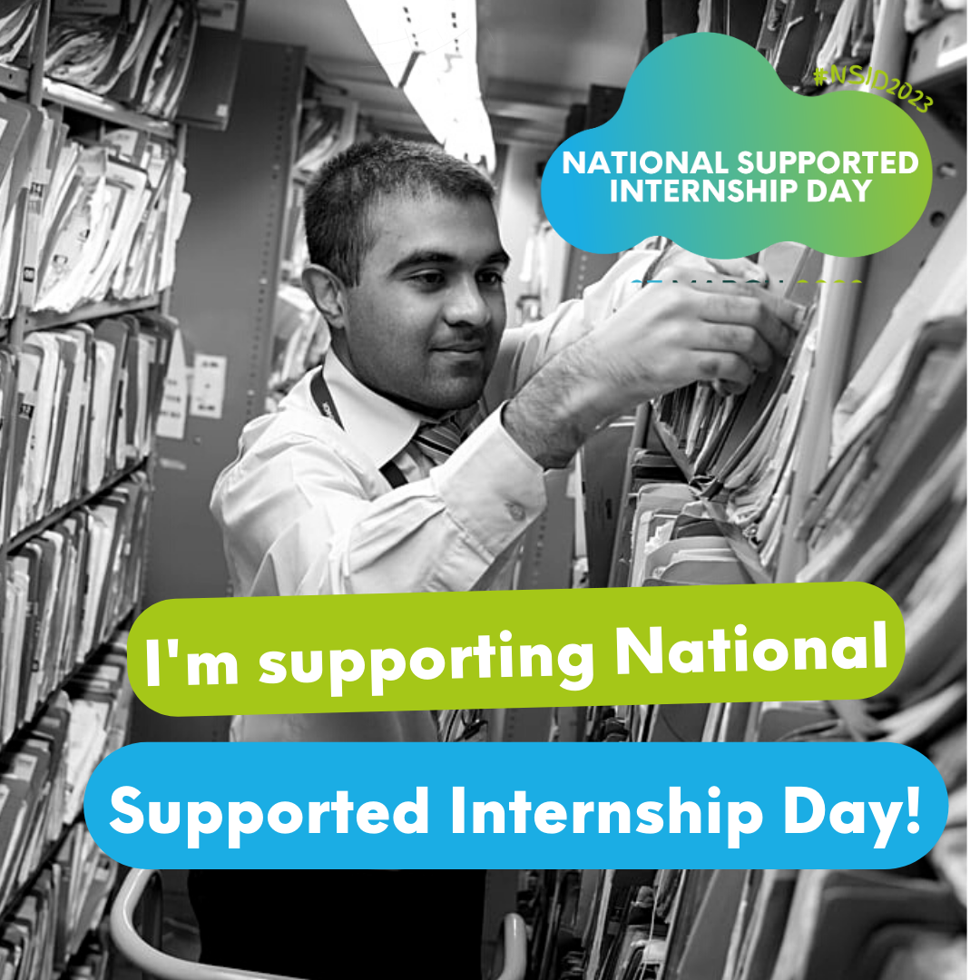

NSID Photo 2
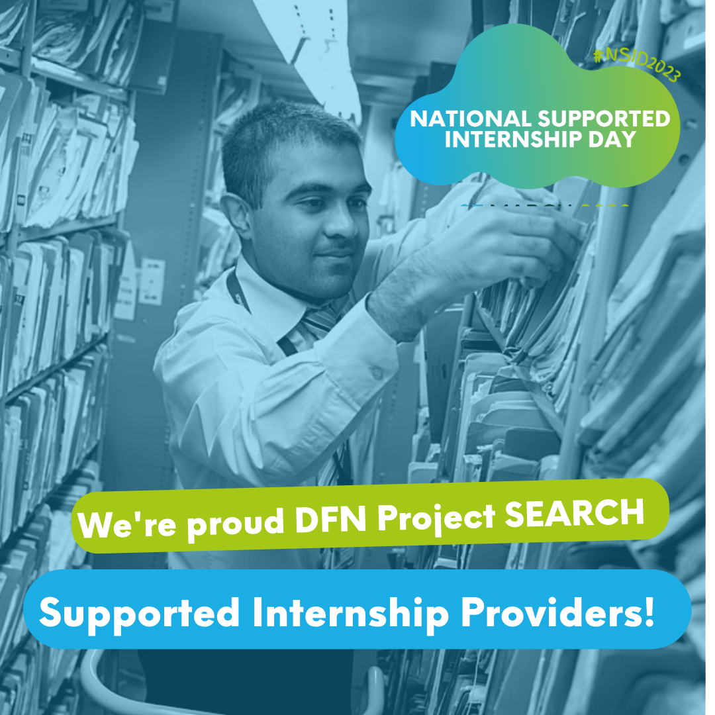

Press Release / Media Relations
We will shortly provide a template press release to share with your network / media contacts if you or the organisation are linked to are taking part in #NSID events.

