Work Choice Successor Arrangements

Transitional Employer Support Grant

Covid-19 Payment Guide for Supported Businesses.

Version 3 – June 2020

Contents
Definitions 3
TESG Payment – Covid-19 7
Background 7
TESG Covid-19 claim form 9
Background 9
Completion of claim form 9
Hints & Tips / Best Practice 13
Claim Form DP229 TESG 16
Annex 1 – Administration of TESG Covid-19 Payment Guide for Supported Businesses 17
Document control 17
Version history 17

Definitions
Work Choice Protected Places (WCPP) – Work Choice is run by the Department for Work and Pensions to help disabled people find work and stay in work. Work Choice can help disabled people learn new skills or find out what it is like to work. Work Choice can also support disabled people who already have a job. Disabled people may get help from Work Choice if they cannot get the support they need from other work-support systems or from their employer. Protected Places is an element of the Work Choice programme.

Baseline – This is the total number of places that are available under Protected Places element of the Work Choice programme. For Transitional Employer Support Grant this is being retained and the baseline numbers as they were agreed at February 2018 will apply. This number is 2,221.

Transitional Employer Support Grant (TESG) – Transitional Employer Support Grant is the first phase of a set of Work Choice Successor Arrangements. TESG is a payment of £5,000 per year to meet the additional support needs of TESG customers.

TESG Customer – There are two groups of TESG customers. They are:
Group 1 – any individual (not formally a participant under a Work Choice contract) who was employed by a Supported Business after 1st September 2018 to fill a vacant Work Choice Protected Place (up to the agreed February 2018 Baseline number as specified by the former Work Choice contract); or
Group 2 – all other individuals (formally participants under a Work Choice contract) not forming part of Group 1 and occupying a Work Choice Protected Place on 31st March 2019.

Supported Business (SB) - A Supported Business is an organisation or ‘business unit’ whose primary objective and product is the facilitation of employment for disabled people as defined within the Equality Act 2010. As an Exemplar Employer a Supported Business provides a specialist supportive environment that goes well beyond reasonable adjustment or adjustment covered by standard Access to Work. A Supported Business enables people to work, allowing for their productive capacity, thus increasing inclusion, independence and wellbeing. Where appropriate for the individual, support is provided to progress to external employment. This definition has been provided by the Supported Business Alliance and British Association of Supported Employment.

DWP AtW Policy – This is the Access to Work Policy team within DWP who are responsible for the maintenance, continued development as well as any new policies in relation to Access to Work.

Access to Work (AtW) – Access to Work is a discretionary grant funding scheme run by the Department for Work and Pensions. The scheme enables those with a disability or health condition who are starting or are in work to overcome the minimum barriers they face due to their disability or health condition. The programme provides funding for those adjustments which are above and beyond what is considered a reasonable adjustment or standard equipment that an employer has a legal obligation to provide.

Access to Work Holistic Assessment – The Access to Work Holistic Assessment explores all relevant factors that impact on an Access to Work customers work place barriers to employment. The purpose of the assessment is to make recommendations on how to overcome these barriers and to provide a Needs Assessment Report to the DWP National Access to Work Team which contains recommendations for the provision/purchase of specialist equipment and adaptations and/or a workplace support worker as appropriate.

Covid-19 / Coronavirus – Covid-19 / Coronavirus is a new notifiable disease. For the latest information on Covid-19 / Coronavirus and what this means please visit gov.uk/covid-19.

Self-isolation – The latest information about how to self-isolate is available on gov.uk/covid-19 stay at home guidance
This information covers people:
• with symptoms that may be caused by coronavirus, and do not need hospital treatment, who must remain at home until they are well
• living in households with someone who shows symptoms that may be caused by coronavirus

Shielding – This is a measure to protect people who are clinically extremely vulnerable by reducing all contact between those who are extremely vulnerable and other people. The guidance explains what we mean by extremely vulnerable.

Furloughed – If you and your employer both agree, your employer might be able to keep you on the payroll if they’re unable to operate or have no work for you to do because of the coronavirus. Although your employer may be able to make a claim for your wage from the Cabinet Office Job Retention Scheme, there is no requirement for the employer to claim this funding as long as the employer is continuing to meet at least the amount of wage that is equivalent to that which would have been paid under the Cabinet Office Job Retention Scheme,

Flexible Furlough – Where an employee has been furloughed for at least 3 consecutive weeks before 30th June 2020, if the employee returned to work and the employer at a future date experiences a downturn in commercial activity and subsequently does not have the work for the employee, as long as the employee has completed the pre-existing conditions then the employer can re-furlough the employee.

Support and Wellbeing – To maintain their work readiness and support any daily tasks the employee requires help with, such as, understanding coronavirus restrictions, bills and general wellbeing.

Work Updates – To maintain the connection with work by providing workplace updates and offer any appropriate training that can be undertaken.

Wellbeing support to maintain Mental Health – To provide wellbeing support to maintain mental health by offering coping strategies and sign posting to appropriate services.

Data protection specific definitions:

DPA – means the Data Protection Act 2018

GDPR – means Regulation (EU) 2016/679 – the General Data Protection Regulation

Controller – determines the purposes and means of processing personal data.

Processor – is responsible for processing personal data on behalf of a controller.

TESG Payment – Covid-19

Background
The Transitional Employer Support Grant went live in April 2019 following the end of Work Choice. At this time there were 2,221 baseline opportunities across 57 Supported Businesses who had previously been part of the Work Choice supply chain as at February 2018.
Acknowledging the concerns of Supported Businesses and continued monitoring of baseline opportunities we have worked collaboratively with the Supported Business Alliance and Supported Businesses to develop a payment guide in response to the Coronavirus pandemic.
In recognition of the extensive adjustments and support that Supported Businesses provide to disabled employees, with Supported Businesses continuing to provide this support during the Coronavirus pandemic to those employees who are furloughed and in receipt of TESG, Secretary of State for Work and Pensions and Minister for Disabled People have agreed that payment of TESG will continue.
This means that where Supported Businesses have employees who are in receipt of TESG from Access to Work and are furloughed, the support can continue to be provided at a distances with the Supported Business providing that support.
In relation to that support, Supported Businesses will be required to provide one hours support a week for each employee who receives TESG. The support provided will need to be undertaken and recorded on the claim form when submitting request for payment from Access to Work. The support will need to cover 3 areas, these are:
- Regular contact
- Work updates
- Well-being support to maintain mental health
During the Coronavirus pandemic, there will not be a new claim form to record the information for this period. The existing DP229TESG claim form will be continuing in use.
We are asking Supported Businesses to work with the disabled person (employee) when completing the form to ensure that the form is completed in full before being submitted to Access to Work for payment.
As HM Government updates guidance for businesses and progresses through it’s roadmap to easing the lockdown whilst restarting the economy, the Chancellor of the Exchequer has announced changes to the Job Retention Scheme.
The changes to the Job Retention Scheme mean that where an employee has been furloughed for at least 3 consecutive weeks before 30th June 2020, if the employer at a future date experiences a downturn in commercial activity and subsequently does not have the work for the employee, as long as they have completed the pre-existing conditions then the employer can re-furlough the employee.
If the employer furloughs the member of staff, they will need to record the date the employee is furloughed.
To received TESG the Support Business will be required to deliver a minimum level of support of 1 hour per week as they have done during the initial period of furlough up to the 30th June 2020.
The business will also need to record when the employee returns to work. This information will need to be reported to the Access to Work policy team in the same way that was notified on 19th May and 1st June 2020 in relation to TESG employees who are furloughed.
But where employees have not been furloughed for at least 3 consecutive weeks before 30th June 2020, they will be unable to access this element as this falls outside of the guidance in relation to flexible furloughing as detailed on gov.uk pages.

TESG Covid-19 claim form

Background
The information below is to assist in making a claim to Access to Work for Transitional Employer Support Grant Payment for employees who are furloughed and are continuing to receive support during the Coronavirus pandemic.
Before the claim form is submitted to Access to Work for payment, you will need to ensure that all sections of the claim form are completed as without the claim form fully completed a payment cannot be made.

Completion of claim form

At this point you will need to fully complete parts 1 the DP229 TESG as shown below.
At part 1 of claim form DP229 TESG, you will need to complete all fields as you would normally.
Example:

At part 2 of the claim form you will need to complete the from and to boxes with the period for which you are claiming. This should be the previous month for example if you were submitting the claim form in May this should be for support delivered in April.

The next part of the claim form is different for employees who are continuing to be supported but are furloughed.

Supported Businesses are required to provide a minimum of 1 hours support each week for disabled employees who received TESG.

You will need to show the total hours of support that have been delivered in each week in the “Number of supported hours received in week” fields.

You will need to complete the rest of part 2 in full.

An example of this on the claim form is below:
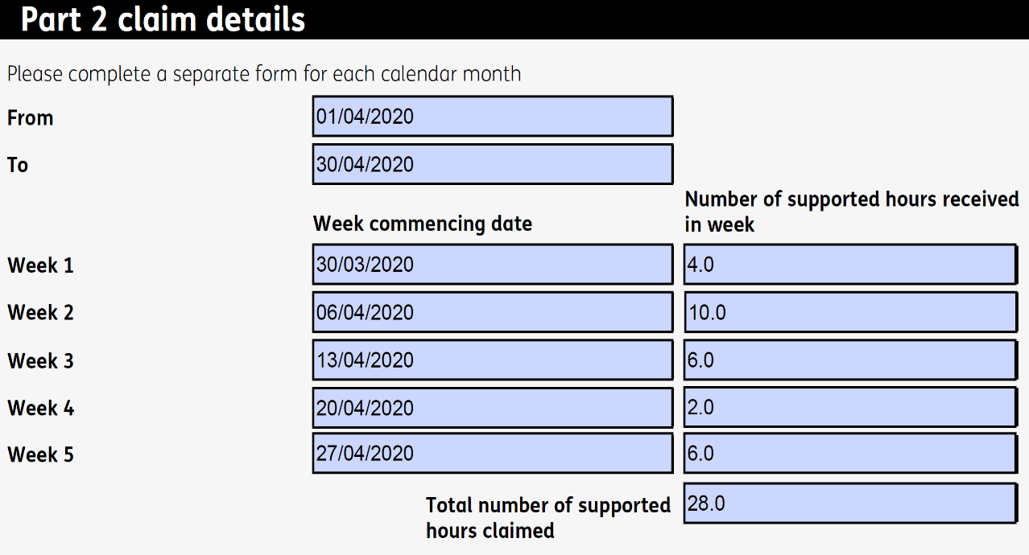

At part 4 you will need to read the declaration and complete the name, company name and address, position and date fields as demonstrated in the example below:

At this point you will need to print the claim form and sign the form at the point indicated in red above “Please sign the form after printing”.

Once printed and signed, you will need to ask the disabled person to complete part 3 of the claim form, as long as they are satisfied with the detail contained within the claim form.

The disabled person will need to provide a physical signature on the claim form at part 3 in the employee signature box along with completing the company name box to ensure that payment is made to the appropriate person.
They will need to ensure the name and date boxes are fully complete.

Now the form is complete, you should send this to the Access to Work payments team:
Access to Work Operational Support Unit
Harrow Kings House Jobcentre Plus
Mail Handling Site A
Wolverhampton
WV98 1JE
Once received the Access to Work payments team will review the claim and make payment as quickly as possible. If the Access to Work payments team need further information they will contact you to advise of the next steps.

Hints & Tips / Best Practice

We recognise Supported Businesses will face various challenges during this difficult time, but to support businesses to overcome some of these challenges we hope the following information will be useful.
We are keen to share best practice and if you do have any hints or tips that you want to share with us please let us know by emailing accesstowork.policytesg@dwp.gsi.gov.uk. We will then collate these and include them within this document.

Physical signatures
Supported Businesses would normally support disabled employees (TESG customers) in the workplace to sign the claim forms. Where employees have been furloughed, obtaining employee signatures will be more challenging.
Access to Work continues to require a physical signature from the disabled employee (TESG customer) in order to pay the grant.
The following provides some options for overcoming the difficulties around obtaining disabled employee signatures.

Option 1

Some Supported Businesses have been working hard to achieve this by posting the completed claim form (excluding the disabled employees signature and date boxes) to the employee to sign and date. The Supported Business will work with the disabled employee to sign and date the claim form and send the form back to the Supported Business who will review the form and forward to Access to Work for payment.
Access to Work are exploring digital channels which may be available to overcome the difficulties a physical signature provides however, at this time the above should assist in being able to achieve a physical signature on the claim form.

Option 2

Emailing claim forms as a reasonable adjustment
Where disabled employees have access to email and are unable to leave the house because they require support and this is not available, the disabled employee can ask Access to Work if they can email their claim forms as a reasonable adjustment.
This will need to be agreed by an Access to Work adviser who will discuss the implications of emailing with them and ask the disabled employee to accept by e mail that they have understood the implications of using email, before it is possible to submit claim forms by email.
Where it is agreed by an Access to Work adviser that claim forms can be e mailed as a reasonable adjustment, the claim form will still need to be completed in full and signed and dated before being submitted to Access to Work for payment.
To do this, the disabled employee will need to scan or take a photograph of all pages of the claim form and attach these to an email.
In the email subject field, the disabled employee will need to add their Access to Work Unique Reference Number (URN) followed by TESG and nothing else.
The email can then be sent to Access to Work at the following email address: atw.contingency@dwp.gov.uk
Any claim forms submitted where there is no agreement for email as a reasonable adjustment will not be processed and the Supported Business will be asked to follow the appropriate guidance to support the disabled employee.

Option 3

Disabled employees whose personal circumstances prevent them from leaving their home
Where disabled employees (TESG customers) are prevented from leaving their home we understand that obtaining a signature from the disabled employee will be difficult.
Supported Businesses will need to continue to support disabled employees remotely and secure the appropriate signatures whilst the disabled employee remains at home.
Some Supported Businesses have told us that they have done this by posting the claim form almost fully completed (excluding disabled employee signature and date) to the disabled employee and talk them through the form, explaining what this means and what they need to do. The Supported Business can then arrange for the form to be collected from them at an agreed time.
This then ensures that the claim form can continue to meet the appropriate standards but also the disabled employee can remain at home.
In addition, the disabled employee could apply to use e mail as a reasonable adjustment (as detailed above) which would remove the need for the Supported Business to collect the claim form.
Note: Where the disabled employee and Supported Business are in a devolved nation (Scotland/Wales), they should follow the advice and guidance in relation to social distancing and other important measures before leaving their home. The guides for each of the devolved nations can be found:
- Scotland
- Wales

Option 4

All options above exhausted
Where the Supported Business has attempted to support the disabled employee to provide a wet signature on the claim form but are unable to achieve this, the Supported Business should hold on to the claim form until a time which it is possible to achieve that signature from the disabled employee.
In response to Coronavirus, Access to Work has extended the timeframe which claims must be made within. Since March 2020, claims for reimbursement of Access to Work grant funding, including TESG, can be made up to 9 months after the date that the costs were incurred.
If there are exceptional circumstances where it will not be possible to achieve a signature, you should contact the Access to Work team who will work with you to understand those difficulties and try to overcome them with you.

Claim Form DP229 TESG

Annex 1 – Administration of TESG Covid-19 Payment Guide for Supported Businesses

Document control
Document title | Work Choice Successor Arrangements – TESG Covid-19 Payment Guide for Supported Businesses
Author/maintainer | Ian Milton, DWP Access to Work Policy team.
Owner | Debbie Bradford, DWP Access to Work Policy team.
Document version/status | Version 3
Date issued | 29/06/2020

Version history
Version | Date | Summary of changes
1 | 19/05/2020 | Document creation.
2 | 29/05/2020 | Updates to clarify text following Supported Business feedback:  - Completion of claim form;  - Hints and tips
3 | 25/06/2020 | Updates to definitions to add in further clarification:  - On the requirement to draw down on the funds available from the Job Retention scheme for employees who are furloughed;  - New definition surrounding flexible furloughing; and  - Updated background section to include more details about flexible furlough.

